Database Management System 2 Endterm

**Zhumadulla Adilet**

**Tanatar Diyat**

**Kudaibergenov Elzhas**

**Aitbay Damir**

**Orynbasar Sabyrzhan**

1. Procedure which does group by information

CREATE OR REPLACE PROCEDURE group_info AS

CURSOR c IS

SELECT Year, COUNT(*) AS num

FROM Product_company

WHERE Year > 2000 --> gets data greater than 2000 years

GROUP BY Year;

BEGIN

FOR r IN c LOOP

DBMS_OUTPUT.PUT_LINE(r.Year || ': ' || r.num);

END LOOP;

END;

--> Calling the procedure which is groups car years

BEGIN

group_info;

END;

1. Function which counts the number of records

CREATE OR REPLACE FUNCTION num_of_rec(Employees VARCHAR2) RETURN NUMBER AS

num_of_rec NUMBER;

BEGIN

EXECUTE IMMEDIATE 'SELECT COUNT(*) FROM ' || Employees INTO num_of_rec;

return num_of_rec;

END;

-- Calling the function

BEGIN

DBMS_OUTPUT.PUT_LINE('Number of records :' || num_of_rec('Employees'));

END;

1. Add user-defined exception which disallows to enter title of item (e.g. book) to be less than 5 characters

DECLARE

p_mark Product_company.Mark%type :=:Enter;

p_model Product_company.Model%type;

p_price Product_company.Price%type;

mark_length NUMBER;

invalid_mark_name EXCEPTION;

BEGIN

mark_length := LENGTH(p_mark);

IF mark_length < 5 THEN

RAISE invalid_mark_name;

ELSE

SELECT Mark, Model, Price INTO p_mark, p_model, p_price

FROM Product_company

WHERE Mark = p_mark;

DBMS_OUTPUT.PUT_LINE('Mark: ' || p_mark);

DBMS_OUTPUT.PUT_LINE('Model: ' || p_model);

DBMS_OUTPUT.PUT_LINE('Price: ' || p_price);

END IF;

EXCEPTION

WHEN invalid_mark_name THEN

dbms_output.put_line('Mark must be at least 5 characters long');

WHEN no_data_found THEN

dbms_output.put_line('No such mark');

WHEN others THEN

dbms_output.put_line('Sorry, error!');

END;

1. Procedure which uses SQL%ROWCOUNT to determine the number of rows affected

CREATE OR REPLACE PROCEDURE row_count AS

update_row NUMBER;

BEGIN

UPDATE product_company

SET price = price || ' -50% discount'

WHERE year = '2009';

update_row := SQL%ROWCOUNT;

DBMS_OUTPUT.PUT_LINE('Number of rows affected: ' || update_row);

END;

BEGIN

row_count;

END;

1. Create a trigger before insert on any entity which will show the current number of rows in the table

CREATE OR REPLACE TRIGGER count_trigger

BEFORE INSERT ON payment

DECLARE

count_pay NUMBER;

BEGIN

SELECT COUNT(DISTINCT payment_type) INTO count_pay FROM payment;

DBMS_OUTPUT.PUT_LINE('How many kinds of payment methods we have: ' || count_pay);

FOR i IN (SELECT DISTINCT payment_type FROM payment) LOOP

DBMS_OUTPUT.PUT_LINE('Payment method name: ' || i.payment_type);

END LOOP;

END;

INSERT INTO payment

VALUES (102, 102, 102, 'cash', 'cash', '450000');

**Normalization in DBMS - 1NF, 2NF, 3NF, 4NF**

## **1NF (First Normal Form) Rules**

* Each table cell should contain a single value
* Each record needs to be unique

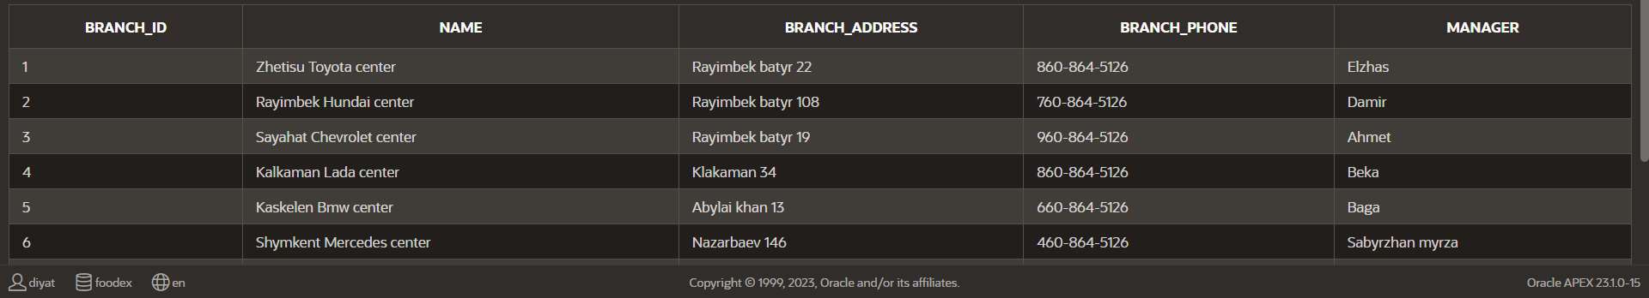

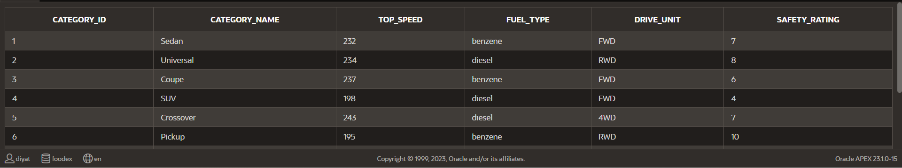

**2NF (Second Normal Form) Rules**

* Be in 1NF
* Single column primary key that does not functionally dependant on any subset of candidate key relation





**3NF (Third Normal Form) Rules**

* Be in 2NF----->1NF + 2NF
* Has no transitive functional dependencies





